Customise all cards

# How to customise the card interface

By default, the Card Interface will display cards in rows of three with an Engage button for Navigation cards as shown in Figure 1. However, the Card Interface also allows you to modify how the card interface is displayed. It allows you to display the same collection of Blackboard items in very different ways.

This document introduces you to the current possibilities and how to use them.

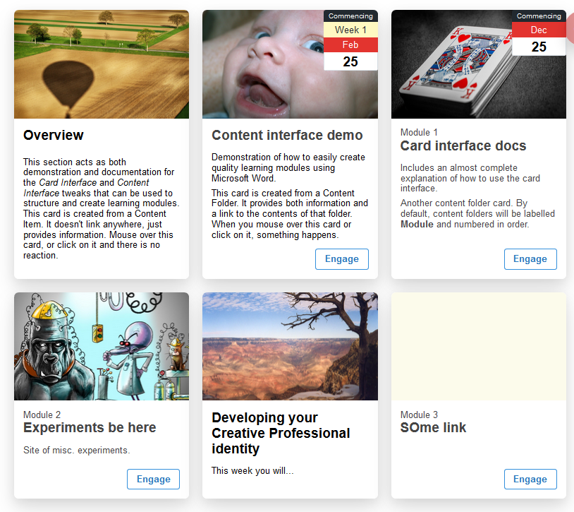

Figure 1 - The default "rows of 3" card interface

# How to customise – Templates and Attributes

The Card Interface supports two types of customisation that impact the entire interface.

* Templates; and,  
  Influencing how the cards are organised on the page.
* Card attributes.  
  Influencing card appearance, e.g. what buttons appear and the labels for those buttons.

While they are used in similar ways, they modify different parts of the interface.

The following two sub-sections summarise the two types of customisation. The rest of this document illustrates how to use them and provides examples.

### Adding parameters to the Card Interface item’s title

Both types of customisation are used by adding the appropriate parameters to the *Name* of the Card Interface item. For example Figure 2 shows the Card Interface item being edited, and the *Name* element having two parameters

1. engage=Start – An attribute to change the label for the engage button to *Start*.
2. template=by4 – A layout parameter that will result in the Card Interface being displayed in rows of 4 cards.

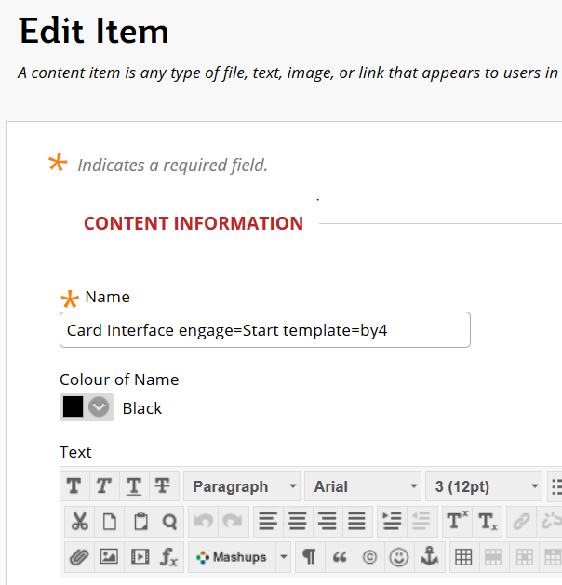

Figure 2 - Adding parameters to the title of the Card Interface item

## Templates

The organisation of cards into rows of individual cards – 3 to a row – in Figure 1 is the default card layout. The following table summarises the currently available layouts.

|  |  |
| --- | --- |
| **Name** | **Description** |
| template=by4 | Show 4 cards per row. The 4 can be replaced with any whole number from 1 through 6. |
| template=assessment | Use a special card design – designed specifically for assessment items – to display cards one per row |
| template=vertical | Show only one card per row. The cards are show vertically with the image displaying to the left hand end of the card.  **Note:** This template is not currently working well. |

## Attributes

It’s also possible to specify certain parameters that will be applied to each card and change attributes of the cards.

|  |  |
| --- | --- |
| **Example** | **Description** |
| noengage | Don’t display the engage button |
| engage=’Some word’ | Replace the *Engage* button label with *Some word* |
| markReviewed=’Check Completed’ | Change the *Mark Reviewed* button label to *Check Completed*. Indicating that the student has yet to mark the card completed/reviewed |
| reviewed=’Completed’ | Change the *Reviewed* button label to *Completed*. |
| noImages | Hide any Card images for all cards. |
| noCardNumber | Hide any card numbers on cards with card labels. |

# How to arrange cards vertically using template=vertical?

The **vertical** customisation of the Card Interface aims to display cards vertically. i.e. one card per row. By adding **template=vertical** to the name of the Card Interface item the card interface shown in Figure 1 is transformed into Figure 3.

**Note:** This feature is somewhat unreliable and generally not recommended for use.

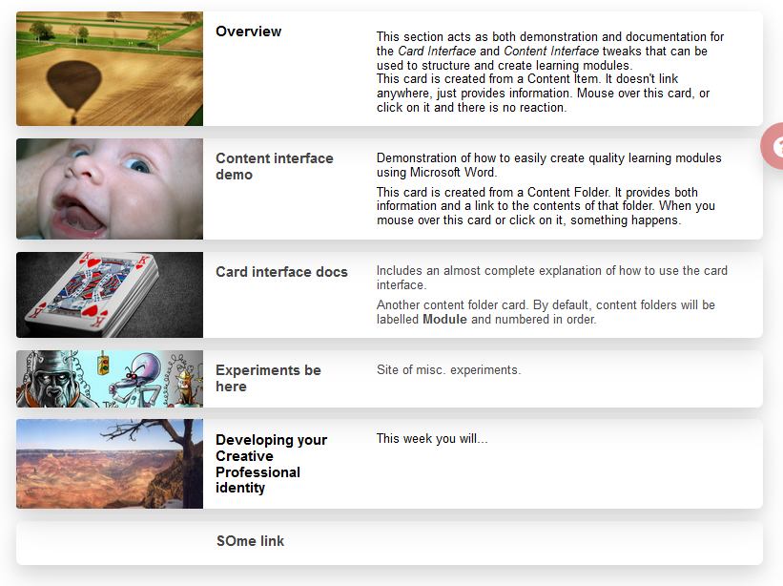

Figure 3 - Vertical Card Interface

# How to change the number of cards per row using template=b1y[123456]?

Change how many cards per row. By default 3, to display 5 cards per row (rather than 3), add **template=by5** to the name of the Card Interface Blackboard item.

Figure 4 shows a by5 card display based on the same Card Interface shown in Figure 1 and Figure 3.

**template=by1** will display 1 card per row. But the Card image will be displayed at the top of the card, rather than to the left-hand side of the Card as done with **template=vertical** (see Figure 3)

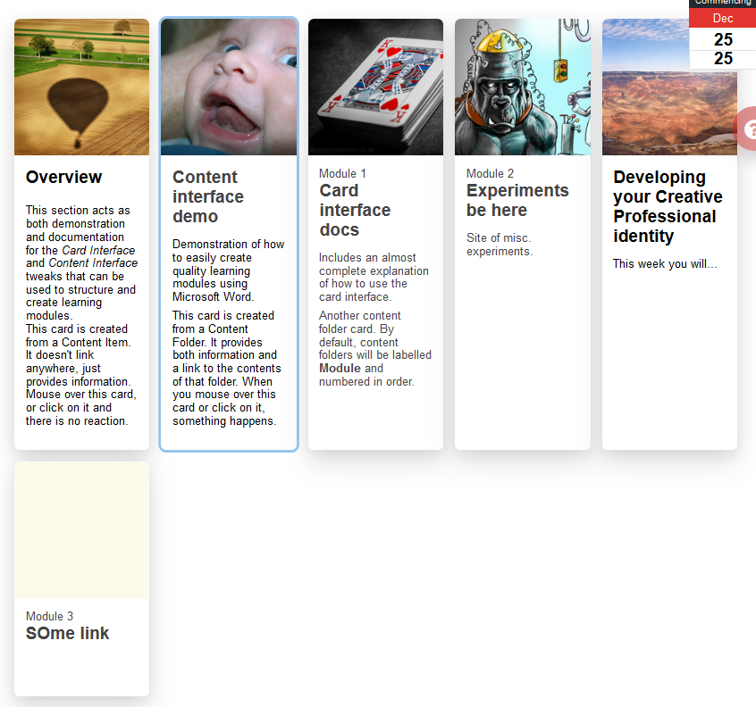

Figure 4 - by5 Card Interface, including bug

# How to use the assessment template - template=assessment?

The assessment template modifies the appearance of the card interface (e.g. Figure 5) to better serve the task of displaying details about a list of assessment items to students. Will use the assessment template to display the cards using a template designed specifically to display Griffith University assessments (see Figure 5).

As well as changing the appearance, the assessment template also ignores some card variables and recognises some new card variables.

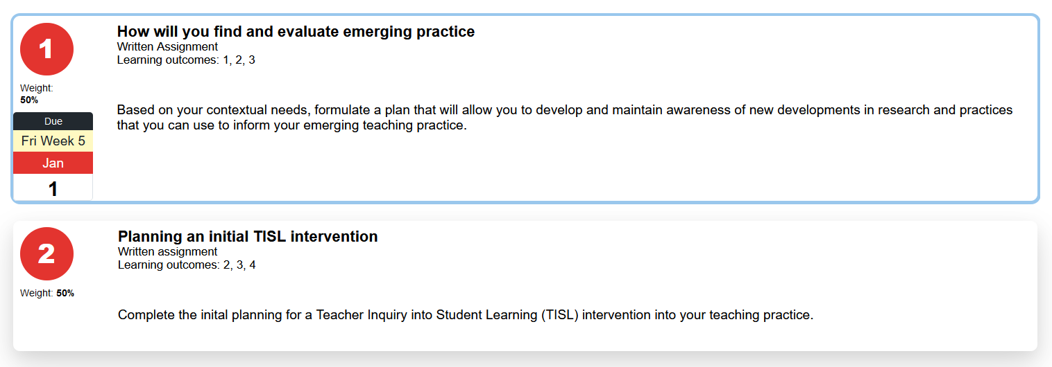

Figure 5 - Example assessment template Card Interface

### Card variables ignored

The assessment template does not include space for either a **Card Label** or a **Card Image** (or associated image variables **Card Image Size**, **Card Image Iframe**).

**Card Image: is still required, any image is just ignored**

Each item to be displayed by the Card Interface using the assessment template must include a **Card Image:** line to indicate it should be displayed. However, any image information will not be used when it is displayed.

### Specific assessment template card variables

The assessment template does recognise some additional card variable summarised in the following table. These variables are informed by information included in course profiles at Griffith University. There are no constraints on the values. The table below shows common example values.

|  |  |  |
| --- | --- | --- |
| **Label** | **Example Values** | **Description** |
| Assessment Type: | Research-based assignment Written assignment Examination – constructed response (More listed in [Griffith policy document](http://policies.griffith.edu.au/pdf/Assessment%20Types.pdf)) | Indicate the type of assessment as outlined in the course profile |
| Assessment Weighting: | 30% | How much % is allocated to the task |
| Assessment Outcomes: | 1,4 | To which course learning outcomes is this assessment intended to check |

### Example assessment template

Figure 5 shows an example assessment template Card Interface. It contains two assessment items: 1 and 2. Each assessment item has a title, a description, and values for each of the assessment template variables listed in the able above.

The **Card Date** and **Card Date Label** variables work exactly as they do for the default Card Interface template. More explanation below.

The first assessment item card in Figure 5 is defined by the Blackboard content item shown in Figure 6. This content item ends with the description that is shown on the card, but it starts with a sequence of card variables, including:

* Card Image:  
  This is left empty as the assessment template does not display an image. However, this variable is necessary to identify this item as one that should be displayed as a card.
* Assessment Type:, Assessment Weighting:, and Assessment Outcomes  
  These are the assessment template specific variables introduced in the table above. Whatever values are provides for these variables are displayed in specific locations on the card as shown in Figure 5.
* Card Date: and Card Date Label:  
  Specify that the date section of the should be displayed as being “due” on the Friday of Week 5 of the course site’s current study period/trimester (e.g. Jan 1).

**Card Date information is not necessary**

If no card date variables are provided, then the card will not display the date widget. As shown in the second card in Figure 5.

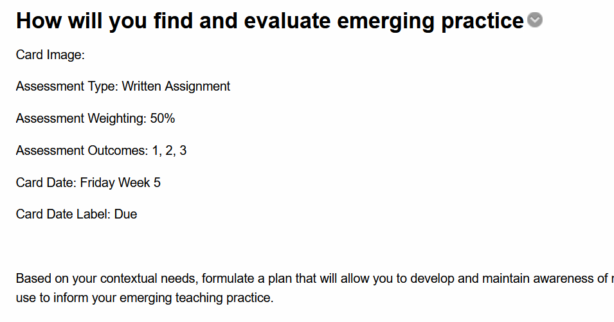

Figure 6 - Content item defining the first assessment item card

# How to change or remove the engage button?

By default the Card Interface displays an **Engage** button at the bottom of each Card that links to some other resource.

Changes you can make to the engage button, include:

1. Remove the engage button; or,
2. Change the label displayed on the button.
3. Changes to the engage button can be made for both the entire collection of cards – explained below - or [each individual card – explained here](https://djplaner.github.io/Card-Interface-Tweak/customiseACard/#changing-a-card's-engage-button).
4. The Card specific method is checked first. It overrides this method.

## Remove the engage button - noengage

Figure 7 displays the card interface almost exactly the same as the default display. Three cards to a row with images. The main difference is that it does NOT display the engage button on each card.

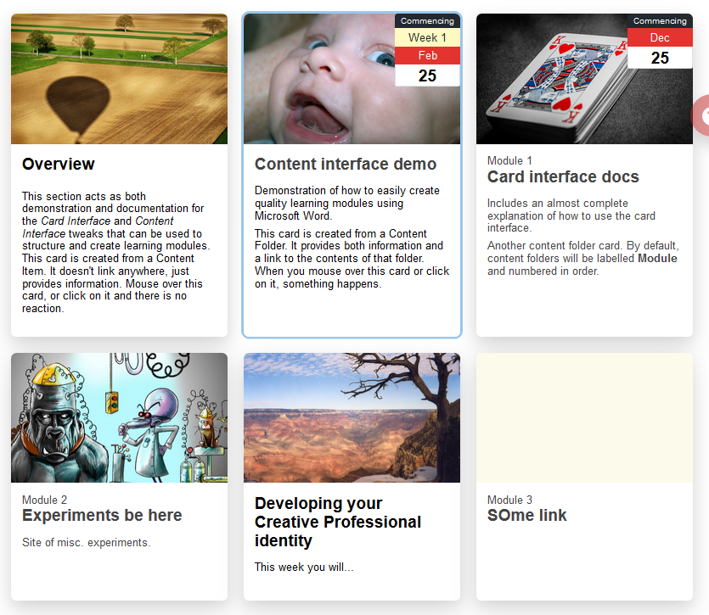

Figure 7 - noengage display

## Change the engage button label

Figure 8 shows a card interface where the **Engage** button label has been changed to **Start**.

**Note:** The first card below doesn’t have a button. That’s because it is an information card. i.e. a card that doesn’t link anywhere, it just displays information. Information cards don’t have an Engage button.

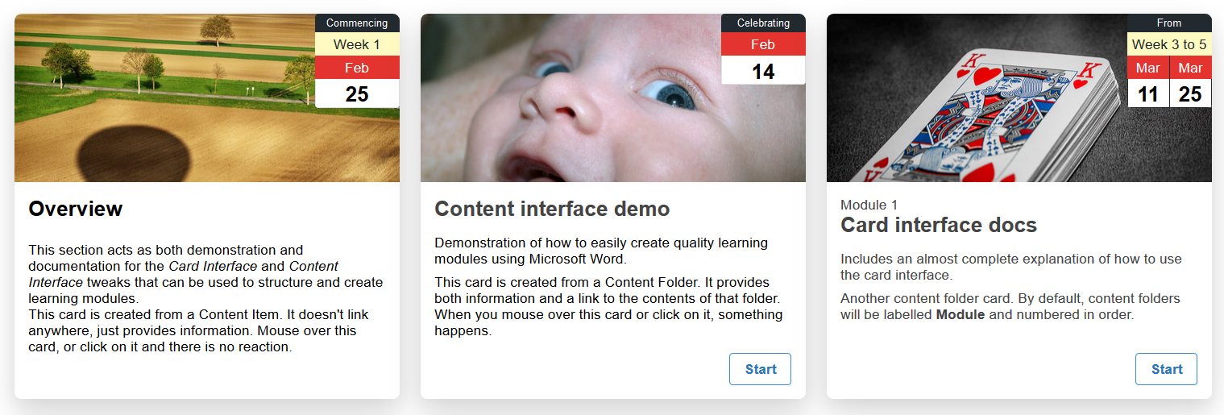

Figure 8 - Card interface with changed Engage button text

To create the change shown in Figure 8 the name of the area within which the cards are displayed (the Card Interface area) has been changed to include **engage=’Start’** (see Figure 9)

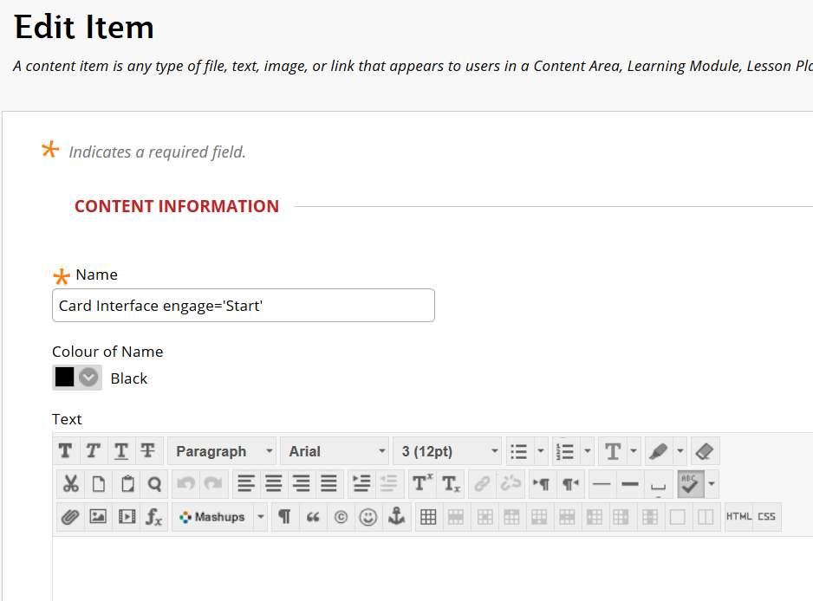

Figure 9 - Editing the card interface to change the Engage button text

# How to change the order of cards?

You change the order of cards by using Blackboard’s interface to change the order of the items on the Blackboard page.

## To change a card, you change the corresponding Blackboard item

The following image has two cards. Each card is implemented using its own Blackboard item (only visible with editing on). To make any changes to a card you must make that change to the corresponding Blackboard item.

The order in which Cards are displayed is the same as the order of the Blackboard items. Change the order of the Blackboard items and you will change the order of the Cards.

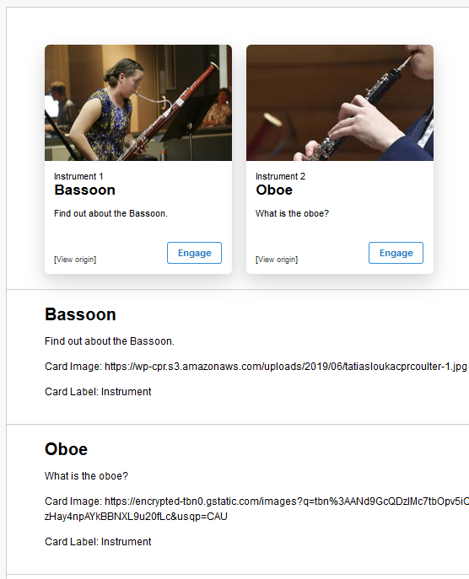

Figure 10 - Order of cards is the same as the order of the Blackboard items

## How to change the order of Blackboard items.

With editing turned on it is possible to drag and drop Blackboard items to change their order. This resource from Reading University in the UK illustrates [how to rearrange Blackboard items](https://sites.reading.ac.uk/tel-support/2019/02/28/blackboard-learn-rearrange-items-in-the-content-pages/).

## Remember to refresh the page

Changing the order of the Blackboard items using the above method won’t change the order of the cards. This is because the Cards are only displayed when the page is loaded from scratch.

Once you’ve finished rearranging the Blackboard items, refresh or reload the web page.

## Numbering is automatically updated

The image below shows the Instrument Cards from above, but re-ordered. The Instrument Cards are using the auto-numbering feature. Each Card has a **Card Label** – *Instrument* – and each Card has been auto-numbered.

Auto-numbering is based on the order of the Blackboard items. Change the order and the auto-number changes. The following shows the Oboe as instrument 1 and the Bassoon as instrument 2. This is different from the first image of the Instrument Cards shown above.

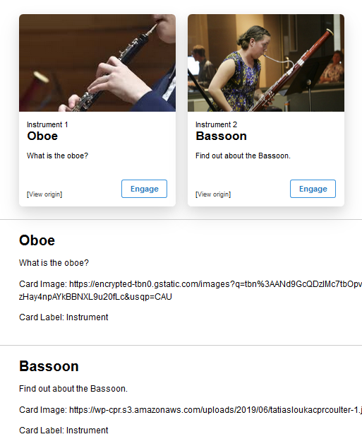

Figure 11 - Change the order of the Blackboard items to change the order of the cards